**Veer Narmad South Gujarat University, Surat.**

**Department of Information and**

**Communication Technology**

**M.Sc. (Information Technology) Programme**

Project Report

**9th Semester**

**M.Sc. (Information Technology)**

**5 Year Integrated Course**

**Year 2024 – 2025**

**CAKESHOP - Online Cake Ordering System**

Guided By : Submitted By:

**Dr. Pushpal Desai** (Internal)  **Kirti Parmar**

(E20110018000610077)

**Shrushti Pastagiya**

(E20110018000610081)

**Veer Narmad South Gujarat University, Surat.**

**Department of Information and Communication Technology**

**M.Sc. (Information Technology) Program**

Certificate

This is to certify that Ms. **Kirti Rameshbhai Parmar** with Exam Seat Number: 1**31** and PG

Registration Number: **E20110018000610077** has worked on her part time project work

entitled CAKESHOP -Online Cake Ordering System.as a partial fulfillment of the requirements for 9th ***Semester - M.Sc. (Information Technology) [5 Year Integrated course]***, during the academic year 2024-2025.

Date: 10-12-2024

Place: Dept. of ICT, VNSGU, Surat.

|  |  |
| --- | --- |
| **Internal Project Guide M.Sc.(I.T.) 9th Semester Department of I.C.T.**  **Veer Narmad South Gujarat**  **University, Surat** | **Head of the Department Department of I.C.T.**  **Veer Narmad South Gujarat University, Surat** |

**INDEX**

|  |  |  |  |  |  |  |  |  |  |  |  |  |  |  |  |  |  |  |  |  |  |  |  |  |  |
| --- | --- | --- | --- | --- | --- | --- | --- | --- | --- | --- | --- | --- | --- | --- | --- | --- | --- | --- | --- | --- | --- | --- | --- | --- | --- |
| |  |  |  | | --- | --- | --- | | Sr no. | Topics | Page no. | | 1 | Introduction  1.1 Project Profile | 5 | | 2 | Proposed System  2.1 Scope  2.2 Objective  2.3 Advantages  2.4 Limitations | 6 | | 3 | System Environment  3.1 Hardware & Software Requirements  3.2 Development Description | 7 | | 4 | System Planning  4.1 Feasibility Study  4.2 Software Engineering Model  4.3 Risk Analysis | 8 | | 5 | System Analysis  5.1 Detailed SRS  5.2 UML Diagram  5.2.1 Use Case Diagram  5.2.2 Activity Diagram  5.3 E-R Diagram | 9 | | 6 | Software Design  6.1 Database Design  6.2 Interface Design | 14 | | 7 | Reference | 26 | |  |

1. **Introduction**
   1. **Project Profile**

**Project Name**

CAKESHOP – Online Cake Ordering System

**Project Description**

The Online Cake Ordering System for cakeshop bakery is designed to provide a seamless and efficient platform for customers to book cakes and bakery products online. This system will streamline the order process, enhance customer experience, and facilitate easy management of orders by the bakery staff.

**System Overview**

The proposed online cake ordering system aims to provide a comprehensive solution for managing cakeshop Bakery's online orders. The system will offer a user-friendly interface for customers to browse products, customize orders, and make secure payments. For the bakery staff, it will provide tools for managing inventory, processing orders, and maintaining customer records.

The proposed online cake ordering system for cakeshop Bakery will enhance the overall customer experience by providing a convenient and efficient platform for booking cakes and bakery items. It will also improve the operational efficiency of the bakery staff by streamlining order management. This system will be a significant step towards modernizing cakeshop Bakery's business processes and expanding its reach to a broader customer base.

**2. Proposed System**

**2.1 Scope**

* Design and development of the website's front-end using HTML, CSS, and JavaScript.
* Implementation of the back-end using .NET MVC and MySQL database.
* Development of features such as user registration, login, product catalog, cake types, order management, and customer feedback.

**2.2 Objective**

* To develop an intuitive online platform where customers can browse, select, and customize cakes and cake types items.
* To implement a user-friendly interface for placing orders.
* To create an efficient back-end system for managing orders, inventory, and customer information.
* To ensure data security and privacy for all transactions and customer details.

**2.3 Advantages**

* An online presence can attract a larger customer base, including those who prefer online shopping.
* Special promotions and discounts can be easily advertised, encouraging more sales.
* Features like customer feedback and reviews help build a community and improve customer satisfaction.
* Integration with secure payment gateways ensures safe and reliable transactions.

**2.4 Limitation**

* Both customers and the bakery rely on stable internet connectivity for using the system.
* Poor internet connectivity can disrupt the ordering process.

**3. Environment Specification**

## **Hardware and Software Requirements**

The efficient hardware and software configuration require to run the system is as suggest below. The configuration suggested is for better performance. Same functionality or higher configuration will always better.

|  |  |
| --- | --- |
| Hardware Configuration | |
| Processor | Intel core 13 11th generation |
| Memory | 4 GB or more |
| Hard disk | 100MB minimum |

|  |  |
| --- | --- |
| Software Configuration | |
| Operating System | Windows, Linux, macOS |
| Browser | Firefox, Chrome, Safari |

**3.2 Development Description**

|  |  |
| --- | --- |
| Development Description | |
| Project Name | CAKESHOP – Online Cake Ordering System |
| Project Type | Web-Based Application |
| Front-end | HTML, CSS, JavaScript |
| Back-end | .NET MVC |
| Database | MySql Server |

**4. System Planning**

**4.1 Feasibility Study**

* **Technical Feasibility:** The technical requirements for the project, such as hardware, software, and development tools, are readily available and feasible to implement.
* **Operational Feasibility:** The online booking system will streamline operations and improve efficiency for Cakeshop Bakery.
* **Economic Feasibility:** The project is economically viable, considering the potential increase in sales and customer reach.

**4.2 Software Engineering Model**

* **Model Selection:** The project will follow the **Agile** methodology to ensure flexibility and adaptability to changing requirements.
* **Iterations:** The development process will consist of iterative cycles, with regular feedback from customers to refine and improve the system.

**4.3 Risk Analysis**

* **Technical Risks:** Potential technical challenges include integration with the Stripe payment gateway and ensuring secure data handling. Mitigation strategies include thorough testing and regular updates.
* **Operational Risks:** Operational challenges may arise from user acceptance and adaptation to the new system. Training and support will be provide to mitigate these risks.
* **Financial Risks:** The project's financial risks include cost overruns and revenue projections. A detailed budget and regular financial monitoring will help manage these risks.

**5. System Analysis**

**5.1 Detailed SRS**

**5.1.1 Users**

* Customers: Individuals who visit the website to browse and order cake items.
* Admin: Admin responsible for managing orders and cakes.

#### 5.1.2 Functional Requirements

User Registration and Login

* Customers can create an account and log in to manage their profile.
* Administrators can manage user accounts and roles.

Product Catalog

* Display a list of available cakes and different types of cakes items with descriptions and prices.
* Allow customers to order specific products.

Order Placement

* Enable customers to select products, specify quantities, and customize orders.
* Provide an add-to-cart functionality with the requirement for user login.
* Allow customers to review their cart and proceed to checkout.

Order Management

* Allow admin to view and process incoming orders.
* Notify customers about their order status via email.

Customized Cake Form

* Display a form with fields for customers to specify their cake preferences, such as flavor, size, icing, decoration, and message.
* Include validation for mandatory fields and provide error messages for incorrect inputs.

Customer Feedback

* Enable customers to provide feedback on their orders.
* Display customer reviews and ratings on the product pages.

**5.2 UML diagram**

**5.2.1 Use case diagram**

**Admin & User**

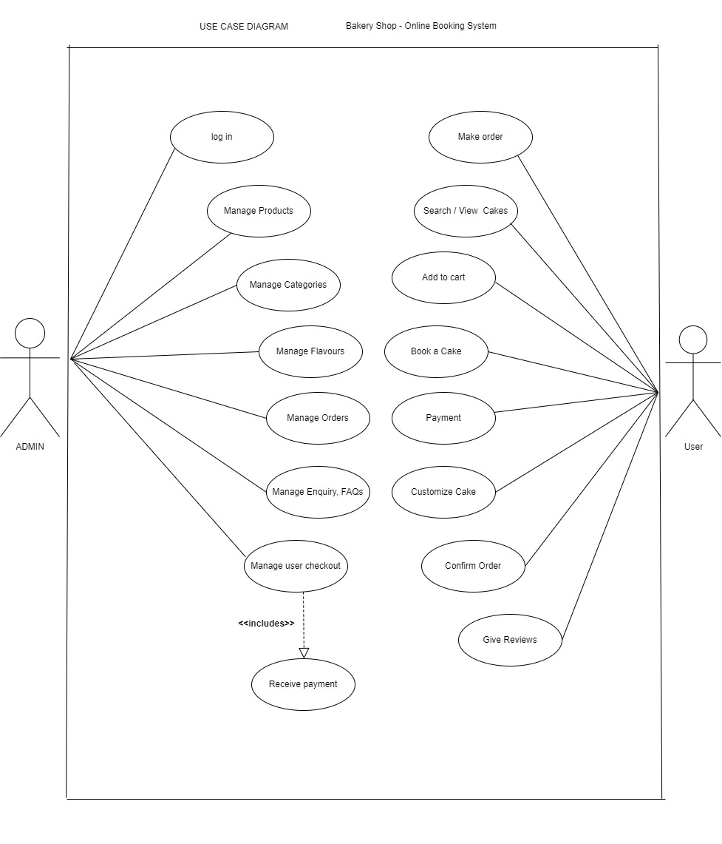

**5.2.2 Activity Diagram (Admin)**

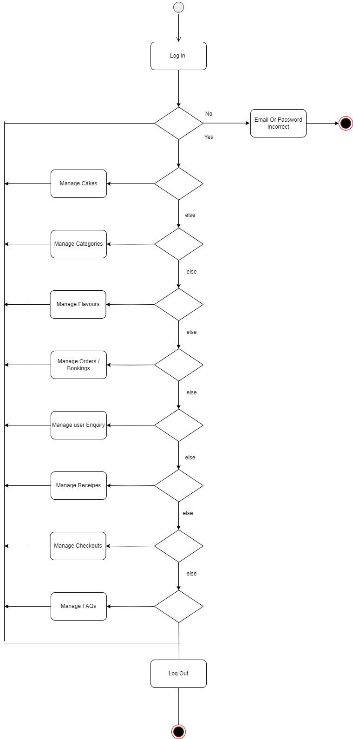

**Activity Diagram (User)**

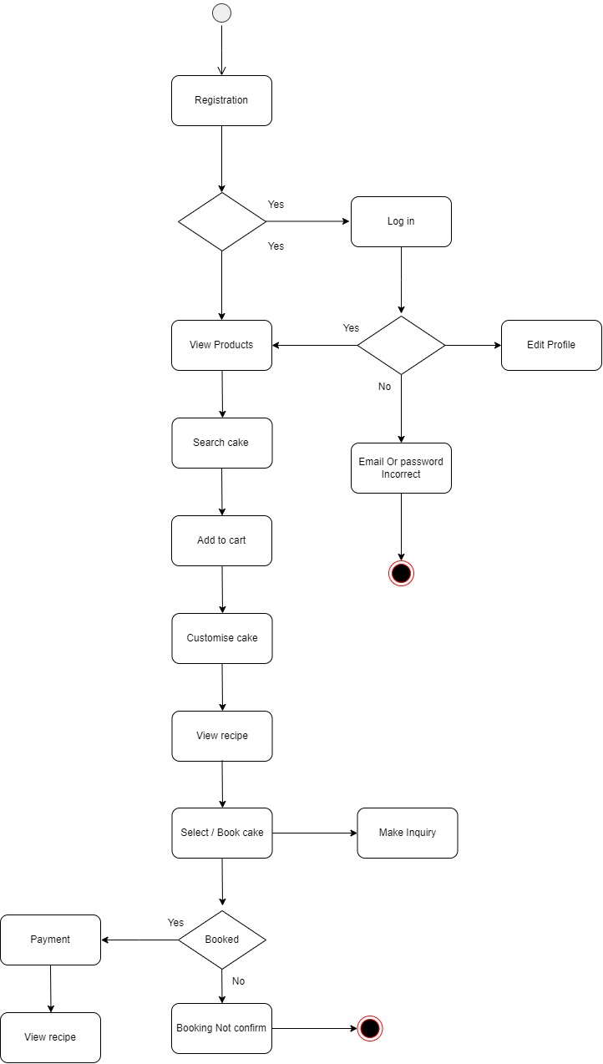



**5.3 ER – Diagram**

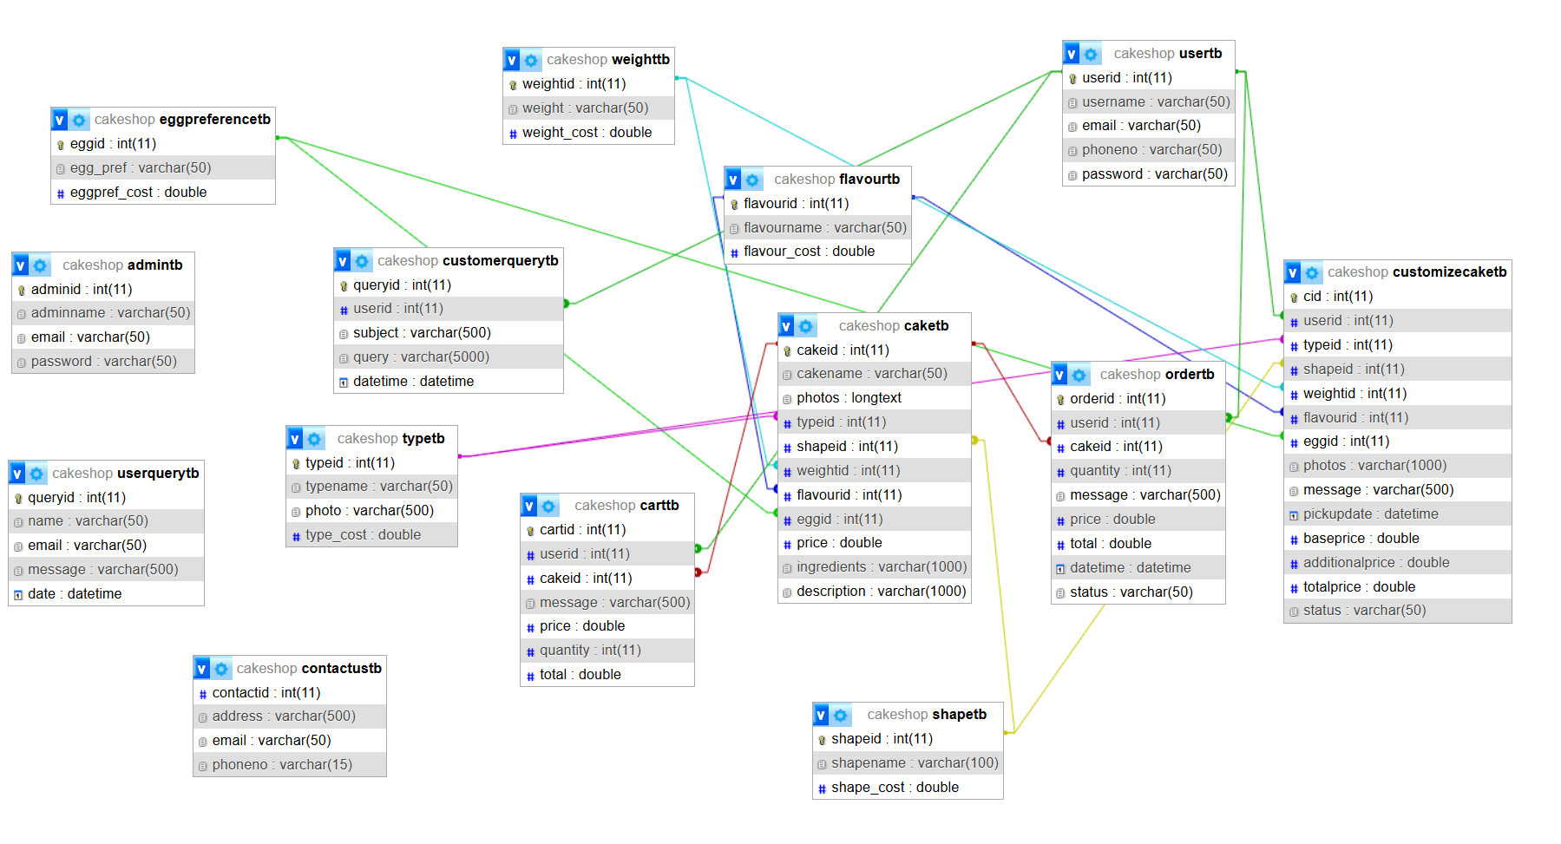

**6. Software Design**

**6.1 Database Design**

|  |  |  |  |
| --- | --- | --- | --- |
| admintb | | | |
| **Element Name** | **Description** | **Data Type** | **Constraint** |
| adminid | Admin id | int | PrimaryKey, AutoIncrement |
| adminname | Name of admin | varchar(50) |  |
| email | Email of admin | varchar(50) |  |
| password | Pswd of admin | varchar(50) |  |

|  |  |  |  |
| --- | --- | --- | --- |
| typetb | | | |
| **Element Name** | **Description** | **Data Type** | **Constraint** |
| typeid | Type id | int | PrimaryKey, AutoIncrement |
| typename | Name of type | varchar(50) |  |
| photo | Photo of type | varchar(500) |  |
| type_cost | Cost of type | double |  |

|  |  |  |  |
| --- | --- | --- | --- |
| shapetb | | | |
| **Element Name** | **Description** | **Data Type** | **Constraint** |
| shapeid | Shape id | int | PrimaryKey, AutoIncrement |
| shapename | Name of shape | varchar(50) |  |
| shape_cost | Cost of shape | double |  |

|  |  |  |  |
| --- | --- | --- | --- |
| flavourtb | | | |
| **Element Name** | **Description** | **Data Type** | **Constraint** |
| flavourid | Flavour id | int | PrimaryKey, AutoIncrement |
| flavourename | Name of flavour | varchar(50) |  |
| flavour _cost | Cost of flavour | double |  |

|  |  |  |  |
| --- | --- | --- | --- |
| eggpreferencetb | | | |
| **Element Name** | **Description** | **Data Type** | **Constraint** |
| eggid | Egg id | int | PrimaryKey, AutoIncrement |
| egg_pref | Egg preference | varchar(50) |  |
| eggpref_cost | Cost of with or  without Egg | double |  |

|  |  |  |  |
| --- | --- | --- | --- |
| weighttb | | | |
| **Element Name** | **Description** | **Data Type** | **Constraint** |
| weighttb | Weight id | int | PrimaryKey, AutoIncrement |
| weight | Name of weight | varchar(50) |  |
| weight _cost | Cost of weight | double |  |

|  |  |  |  |
| --- | --- | --- | --- |
| caketb | | | |
| **Element Name** | **Description** | **Data Type** | **Constraint** |
| cakeid | Cake id | int | PrimaryKey, AutoIncrement |
| cakename | Name of cake | varchar(50) |  |
| photos | Photo of cake | longtext |  |
| typeid | Type id | int | Foreignkey |
| S hapeid | Shape id | int | Foreignkey |
| weightid | Weight id | int | Foreignkey |
| flavourid | Flavour id | int | Foreignkey |
| eggid | Egg id | int | Foreignkey |
| price | Price of cake |  |  |
| ingrediants | Ingreadiants which is  used in cake | varchar(1000) |  |
| description | Description of cake | varchar(1000) |  |

|  |  |  |  |
| --- | --- | --- | --- |
| carttb | | | |
| **Element Name** | **Description** | **Data Type** | **Constraint** |
| cartid | Cart id | int | PrimaryKey, AutoIncrement |
| userid | User id | int | Foreignkey |
| cakeid | Cake id | int | Foreignkey |
| message | Message that user  want to tell admin  for cake | varchar(500) |  |
| price | Price | double |  |
| quantity | Quantity | int |  |
| total | Total Price | double |  |

|  |  |  |  |
| --- | --- | --- | --- |
| customizecaketb | | | |
| **Element Name** | **Description** | **Data Type** | **Constraint** |
| cid | Customised cakeid | int | PrimaryKey, AutoIncrement |
| userid | User id | int | Foreignkey |
| typeid | Type id | int | Foreignkey |
| shapeid | Shape id | int | Foreignkey |
| weightid | Weight id | int | Foreignkey |
| flavourid | Flavour id | int | Foreignkey |
| eggid | Egg id | int | Foreignkey |
| photos | Photo of cake | varchar(1000) |  |
| message | Message that user  Want to say admin  about cake | varchar(500) |  |
| pickupdate | Pick up date | datetime |  |
| baseprice | Commom Cake price | double |  |
| additionalprice | Add on attributes price | double |  |
| totalprice | Final price | double |  |
| status | “pending”, “approved” | varchar(50) |  |

|  |  |  |  |
| --- | --- | --- | --- |
| ordertb | | | |
| **Element Name** | **Description** | **Data Type** | **Constraint** |
| orderid | Contactus id | int | PrimaryKey, AutoIncrement |
| userid | User id | int | Foreignkey |
| cakeid | Cake id | int | Foreignkey |
| quantity | Quantity of cake | int |  |
| message | message | varchar(500) |  |
| price | Price of cake | double |  |
| total | Total price based  on qty | double |  |
| datetime | Order datetime | datetime |  |
| status | “pending”,”approved” | varchar(50) |  |

|  |  |  |  |
| --- | --- | --- | --- |
| usertb | | | |
| **Element Name** | **Description** | **Data Type** | **Constraint** |
| userid | User id | int | PrimaryKey, AutoIncrement |
| username | Name of user | varchar(50) |  |
| email | Email of user | varchar(50) |  |
| phoneno | Phoneno of user |  |  |
| password | Pswd of user | varchar(50) |  |

|  |  |  |  |
| --- | --- | --- | --- |
| contactustb | | | |
| **Element Name** | **Description** | **Data Type** | **Constraint** |
| contactid | Contactus id | int | PrimaryKey, AutoIncrement |
| address | Address of cakeshop | varchar(50) |  |
| email | Email of cakeshop | varchar(50) |  |
| phoneno | Phoneno of cakeshop | varchar(50) |  |

|  |  |  |  |
| --- | --- | --- | --- |
| customerquerytb | | | |
| **Element Name** | **Description** | **Data Type** | **Constraint** |
| queryid | Query id | int | PrimaryKey, AutoIncrement |
| userid | User id | int | Foreign key |
| subject | Subject of query | varchar(500) |  |
| query | Query message | varchar(500) |  |
| datetime | datetime of query | datetime |  |

**6. Interface Design**

### AdminSide:

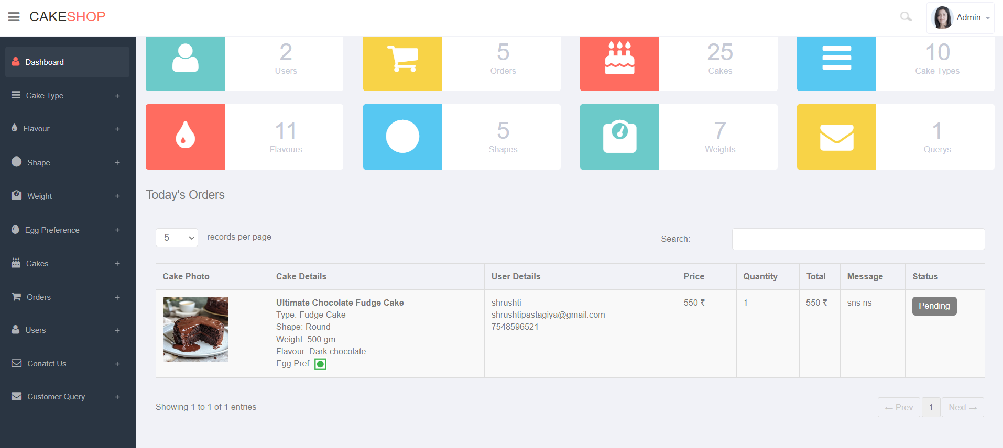+

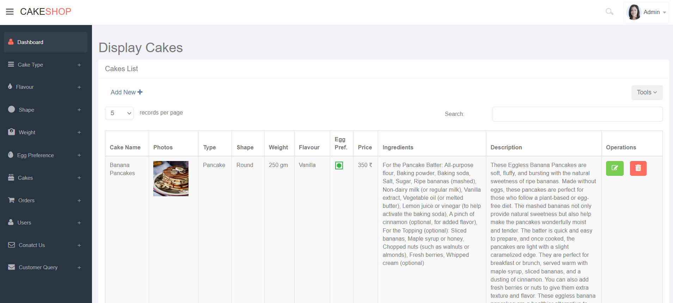

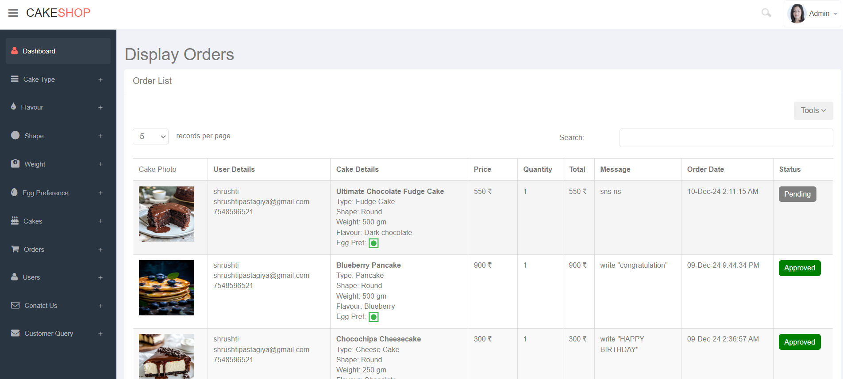

### UserSide:

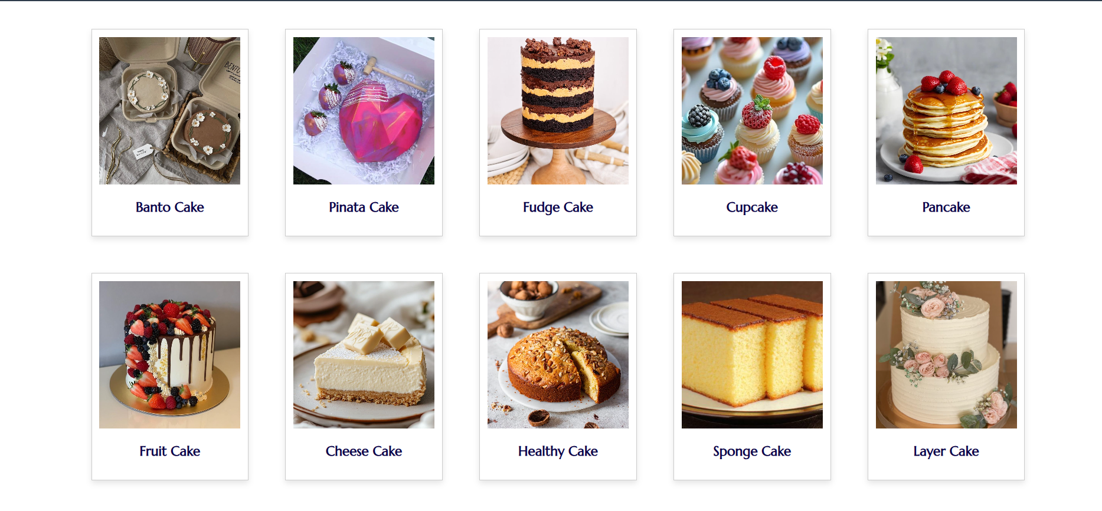

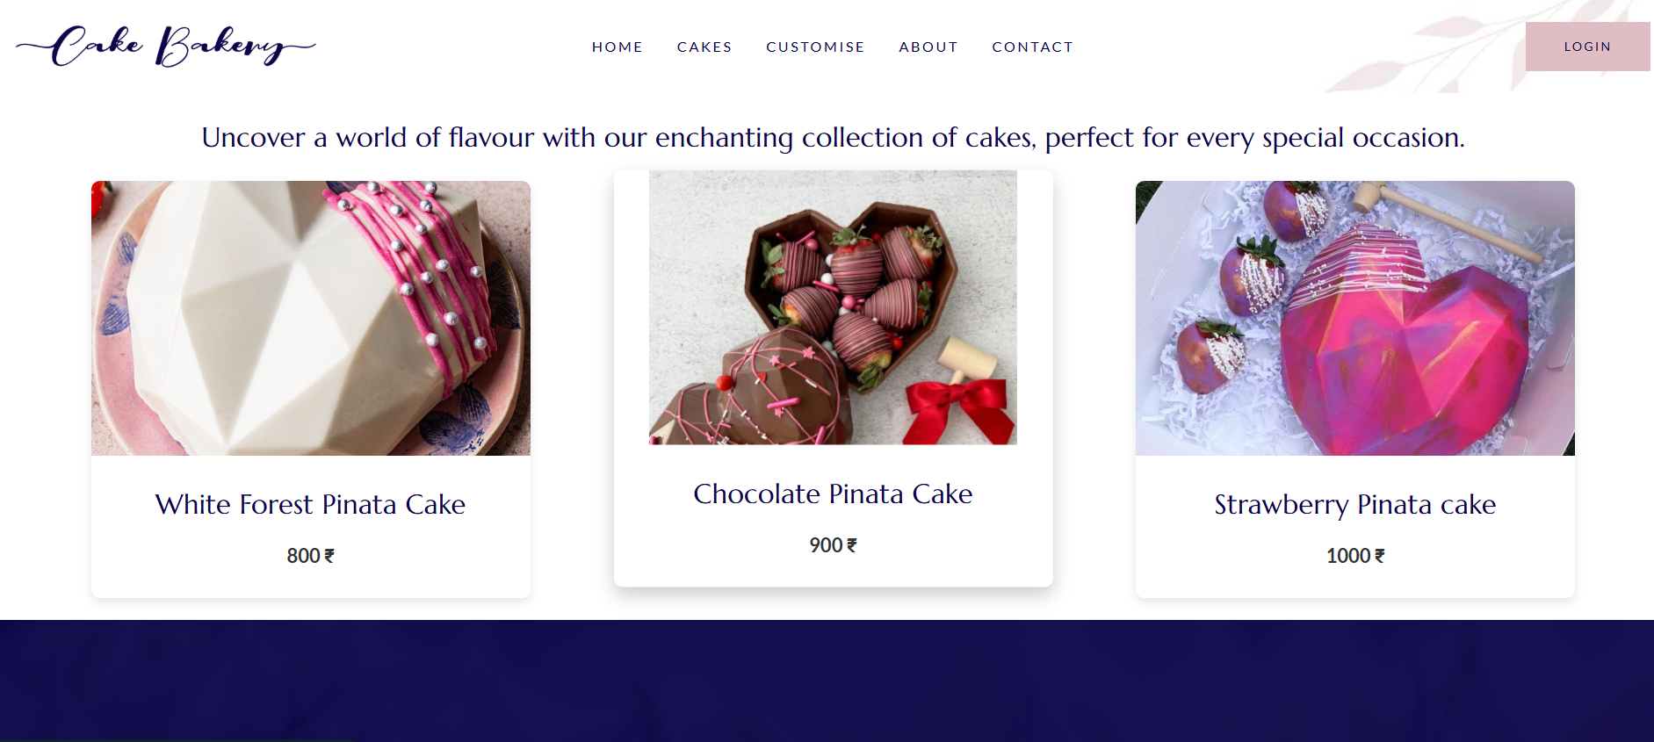

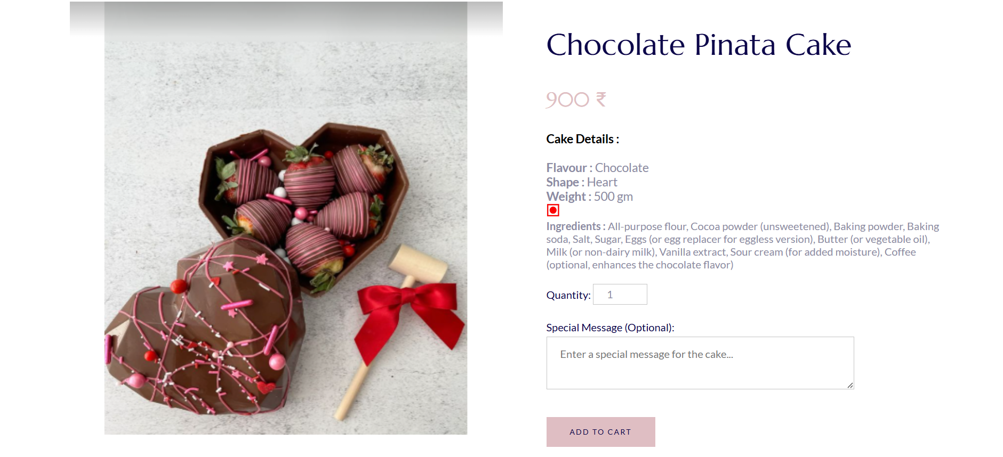

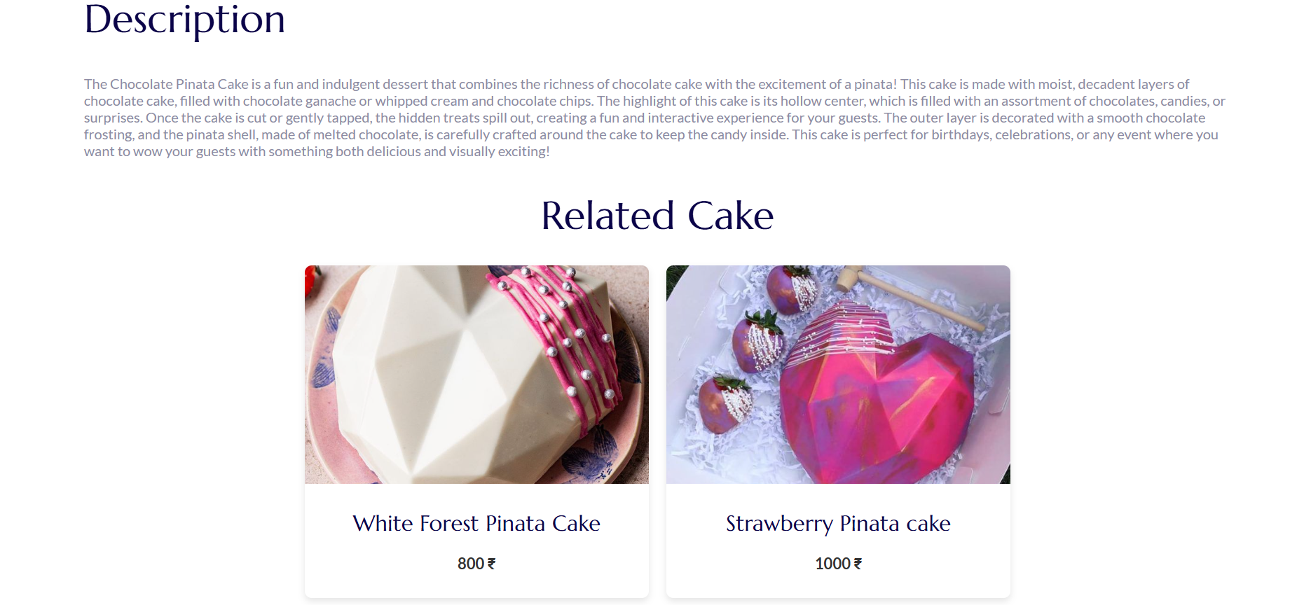

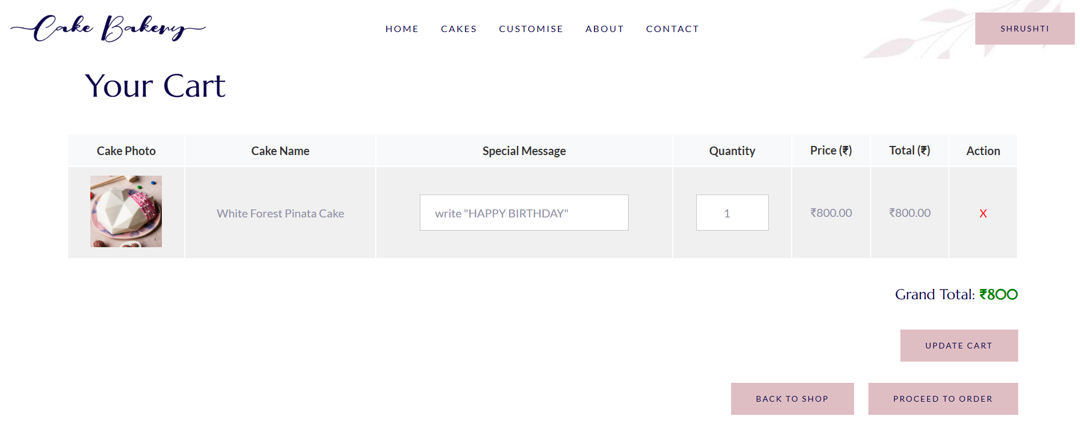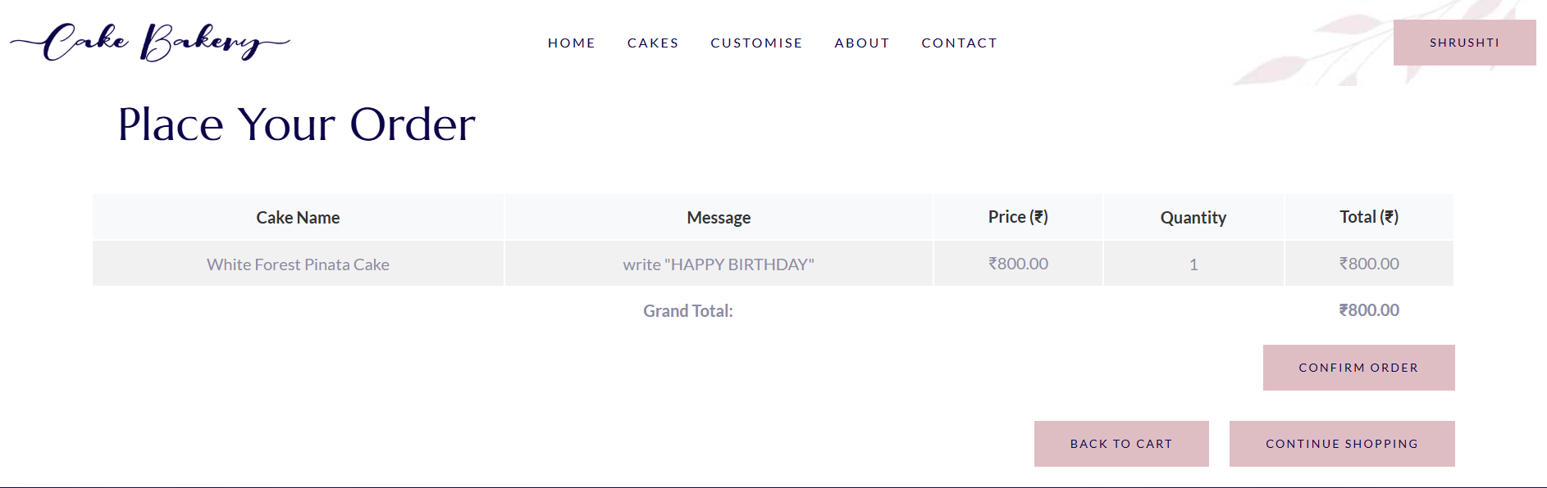

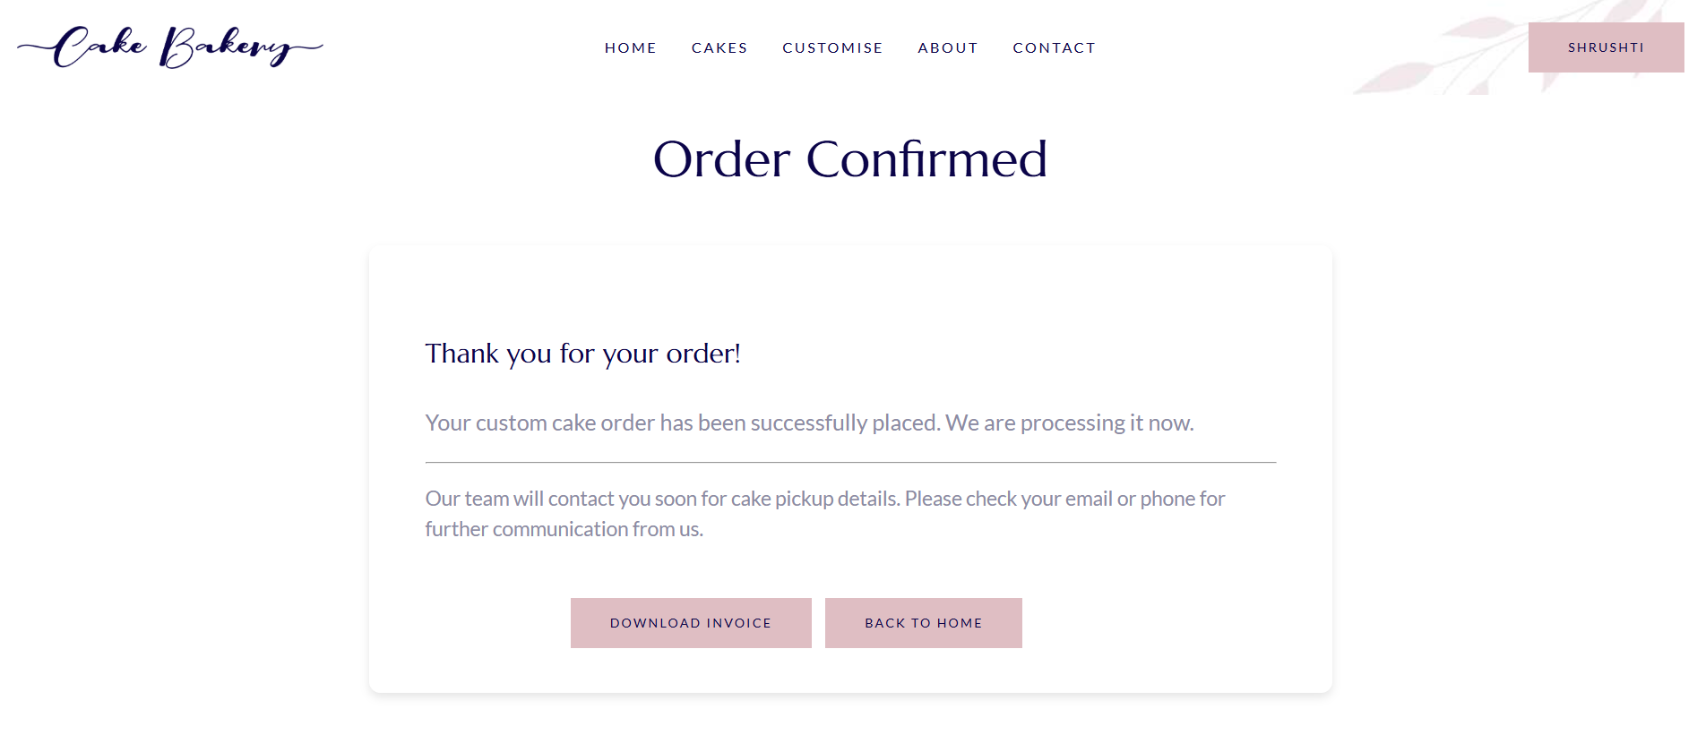

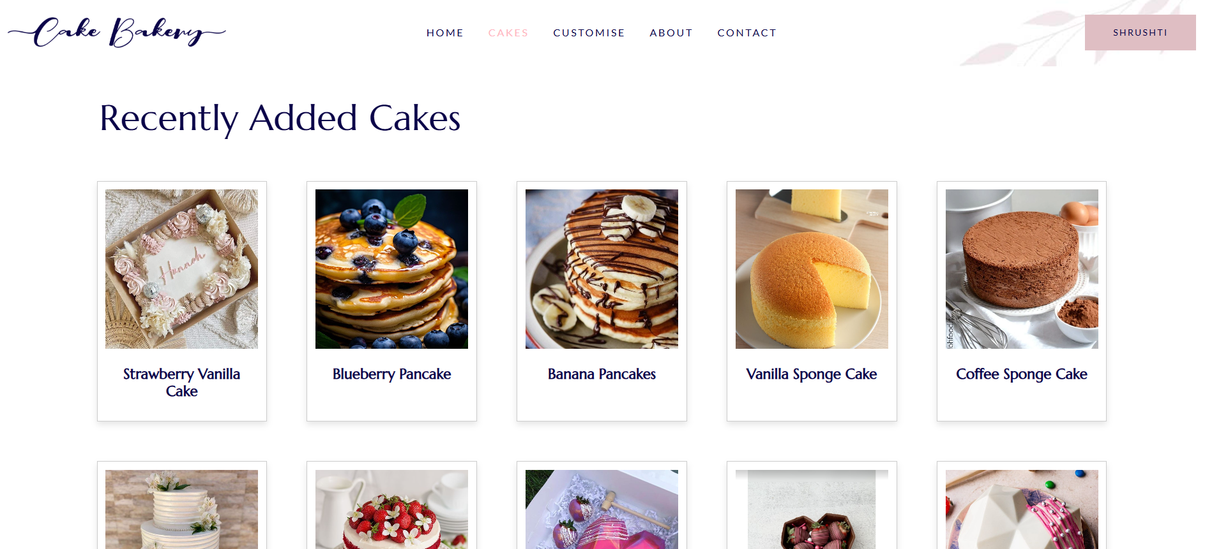

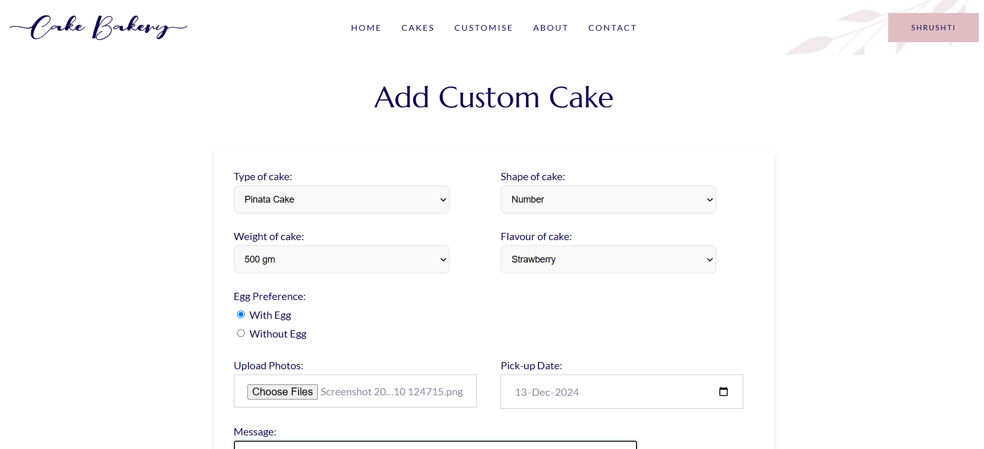

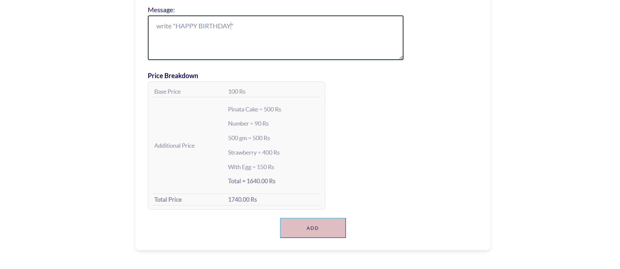

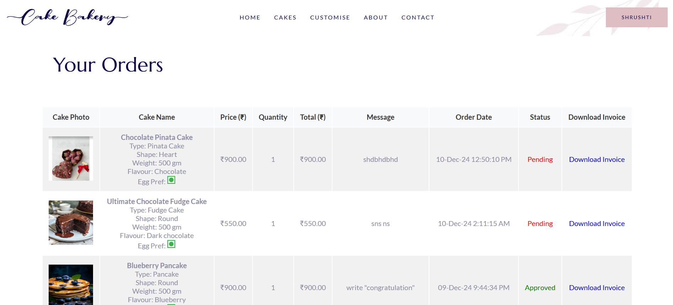

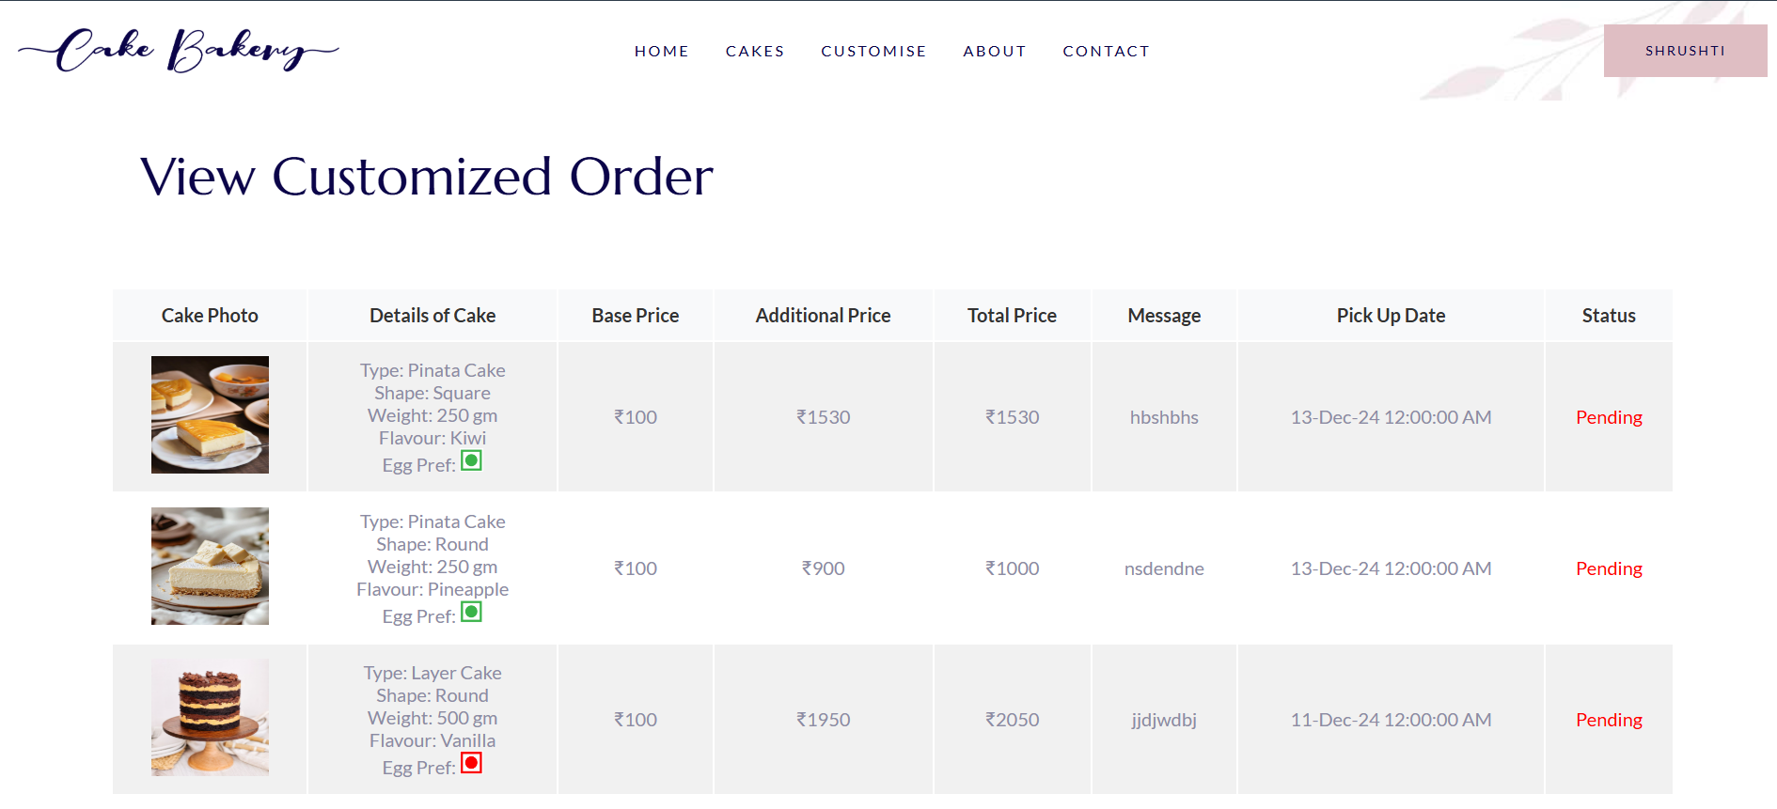

**7. Reference**

[chat.openai.com](http://chat.openai.com)

<https://www.w3schools.com>

[www.youtube.com](http://www.youtube.com)